ARGENTINA’S CULTURE
We will talk about:
- Language: The spoken languages of Argentina number at least 40
- Literature: Argentina has a detailed literary history, as well as one of the region's most active publishing industries.
- Visual arts: Argentine painters and sculptors have a rich history
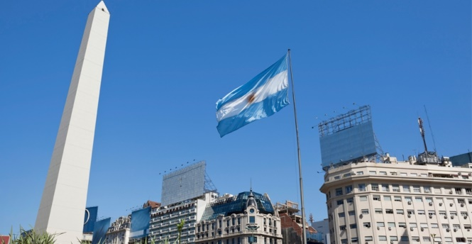
Continue reading for learning more!!

